
SOFTWARE REQUIREMENTS SPECIFICATION
AgizaSafe - A DIGITAL ORDER MANAGEMENT SYSTEM


UNIVERSITY OF DAR ES SALAAM COMPUTING CENTRE
P.O. Box 35062

AgizaSafe
VERSION HISTORY
VERSION | DATE | AUTHOR | DESCRIPTION
1.0 | 20/08/2026 | Aline Abdon | First draft
1.1 | 28/08/2026 | Aline Abdon | Some changes were done on the TO-BE Ordering diagram and functional requirements.
1.2 | 02/09/2026 | Aline Abdon | Changed small part of To-Be Ordering process, functional requirements and added data dictionary.
1.3 | 11/09/2026 | Aline Abdon | Modified the Functional requirements, data dictionary, made changes to the pictorial diagrams and narratives to ensure they’re consistent with the wording.

Table of Contents
INTRODUCTION 3
PURPOSE OF DOCUMENT 3
AUDIENCE 3
BRIEF SUMMARY OF THE BUSINESS 4
PROBLEM STATEMENT/BUSINESS CHALLENGES 5
SCOPE 6
IN SCOPE (List of things that will be addressed by the project) 6
OUT-OF-SCOPE (List of things that will not be addressed by the project) 10
USER CLASSES, ROLES & RESPONSIBILITIES. 11
BUSINESS PROSPECTS (AS IS) 13
BUSINESS PROSPECTS (TO BE) 17
FUNCTIONAL REQUIREMENTS 22
NON-FUNCTIONAL REQUIREMENTS 31
HARDWARE REQUIREMENTS 34
ASSUMPTIONS & CONSTRAINTS 35
ACCEPTANCE CRITERIA 36
CONCLUSION 49

PROJECT: AgizaSafe –A DIGITAL ORDER MANAGEMENT SYSTEM

INTRODUCTION
The purpose of this Software Requirement Specification document is to demonstrate the development of a web application that will allow customers to place online orders for various products and facilitate the order process fulfillment from the customer service department to the customer themselves. The document will also outline the functional and non-functional requirements of the development of the application, describe the business as it is and how it will be modified and managed by the application.

PURPOSE OF DOCUMENT
The purpose of the document is to clearly define what the AgizaSafe system is expected to do and the standards it should meet. The document will:
- Define scope of the system
- Describe the client’s business and the current challenges
- Identify different system users and define responsibilities of each user
- Specify functional and non-functional requirements of the system
- Define information that system should manage
- Identify proposed hardware requirements
- Provide common reference for developers, testers, analysts and client.

AUDIENCE
AUDIENCE | ROLES
System Developers | They will use the document to understand functions, rules and expected behavior of the system.
System Analysts | They will use the document to analyze requirements and ensure proposed system addresses identified business problems.
System Testers | They will use functional & non-functional requirements to develop test cases and verify system behaves as expected.
Project Managers | Use document to understand project scope, requirements and development priorities.
Client/Administrator | Use the document to verify the proposed system meets needs of the business.
Customers | These are the primary end users of the system and will benefit from easier ordering and order tracking

BRIEF SUMMARY OF THE BUSINESS
The client, Lisa Geoffrey, is a businesswoman who acts as a link between small-scale customers and product sources, particularly for products that customers want to obtain from China and other countries. She assists customers in obtaining required products without requiring them to travel or communicate directly with product sources themselves.
The business currently uses WhatsApp as an important communication channel through which customers send their product requirements and place orders. Lisa then receives the requests, communicates with relevant product sources, confirms the availability and requirements of the requested products, and coordinates the ordering process.
Lisa is not the main source or owner of the products. Therefore, the business does not operate primarily on the basis of Lisa maintaining a physical inventory of all products requested by customers. Product information recorded in the system is mainly used to identify, describe and manage products or product requests handled through the business.
The proposed AgizaSafe system will transform the current process from mainly WhatsApp conversations and handwritten records into a structured digital order-management process. It allows customers to submit product requirements, whole Lisa and the responsible staff can receive, review, source and process those requests, generate invoices, manage payments, update order progress and allow customers to track their orders.

PROBLEM STATEMENT/BUSINESS CHALLENGES
- Manual Record Keeping; The client currently relies on handwritten records to manage customer and order information. This makes maintaining accurate records difficult as the number of customers and orders increases.
- Difficulty Retrieving Information; Finding information about a particular customer or previous order from handwritten records and WhatsApp conversations can be time-consuming
- Difficulty Tracking orders; Customers currently have limited visibility of the progress after submitting their product requirements.
- Increasing Customer Requests Number; Managing a growing customer requests manually increases the possibility of delays, misplaced information and human error.
- Product Sourcing Coordination; Difficulty in organizing customer requirements and coordinating the sourcing process without losing or confusing product details.

SCOPE

IN SCOPE (List of things that will be addressed by the project)
- USER ACCOUNT MANAGEMENT
The System shall provide:
- User Registration
- Login
- Password Recovery
- Phone number entry using appropriate country code
- User profile management
- Two factor authentication/OTP verification

- CUSTOMER MANAGEMENT
The administrator shall be able to:
- Register customers
- View customer information
- Search for customers
- Maintain customer records
Customer information include:
- Customer ID
- Customer names (First, Middle, Last name)
- Phone Number
- Email address
- Business sector
- Business name
- Business address
These fields are identified in the application’s roadmap.
- PRODUCT/ITEM MANAGEMENT
The system shall allow product information stored in the system to be used as reference for products or items requested or previously handled through the business. For product requested by a customer, actual availability and applicable price shall be confirmed through the product-sourcing process before the order is finalized.
Product information may include:
- Product name
- Product category
- Brand
- Size
- Color
- Unit price
- Currency
- Product image
- Product description
- ORDER PLACEMENT
Customers shall be able to submit orders by providing their product requirements.
Customers may select a product from available product information or submit a custom product request when the required product is not listed.
Order information:
- Order number
- Customer ID
- Product/item details
- Quantity
- Product Category
- Brand
- Size
- Color
- Product image
- Description
- Date
- Status
After order has been submitted, Lisa or the responsible administrator shall review the request and coordinate with the relevant product source to confirm the availability and requirements of the requested product before the order proceeds to final processing.
- ORDER MANAGEMENT
The Administrator shall be able to:
- Receive orders
- View order details
- Confirm orders
- Process orders
- Update order status
- Search orders
- View order history
- ORDER TRACKING
The system shall provide customers with visible order progress.
TRACKING STAGES:
Order placed Order confirmed Product sourced Purchased Shipped Arrived Delivered
- ORDER HISTORY
The administrator should be able to able to search historical records using:
- Customer ID
- Order ID
- Product
- Date
The customer also be able to view previous orders.
- NOTIFICATIONS/MESSAGES
The system shall provide notifications relating to order updates. Example:
“Your order AG001 has been confirmed”
Notifications may be generated when an important order status changes.
- DASHBOARD
Customer dashboard shall provide access to:
- My profile
- Place an order
- My orders
- Track order
- Order history
- Messages/Notifications
- Reviews & Ratings
- Contact Administrator

OUT-OF-SCOPE (List of things that will not be addressed by the project)
• Full accounting and financial management.
• Advanced business intelligence and analytics.
• Complex supplier/vendor management.
• Full logistics management.
• Integration with external ERP systems.
• Automated international shipping-provider integration.
• Advanced artificial intelligence functionality.
• Multi-country tax management.
• Automated customs management.
• Native Android/iOS applications in the initial web implementation.
These exclusions will help system focus on core order-management problem.

USER CLASSES, ROLES & RESPONSIBILITIES.

User | Roles | Responsibilities
Administrator/Client | System and business administrator | Manage customers, orders & products
Customer | End user | Register, place and track orders

Administrator
- Business owner/operator who manages the system.
Responsibilities:
  - Log into the system
  - Register customers
  - View customer records
  - Search customer records
  - Add product information
  - View incoming orders
  - Confirm orders
  - Process orders
  - Update order status
  - Search previous orders
  - View order history
  - Send & trigger customer notifications
  - Manage administrator profile information
Customer
- Is the end user who uses the system to request products and monitor orders.
Responsibilities:
  - Create account
  - Log in
  - Provide required personal information
  - Place orders
  - Provide product requirements
  - View submitted orders
  - Track order progress
  - View previous orders
  - Receive notifications
  - Contact administrator

BUSINESS PROSPECTS (AS IS)
This is about the way business way carried out by the client before the system is introduced.
It involves the following classes:
- Customer
- Client/Administrator

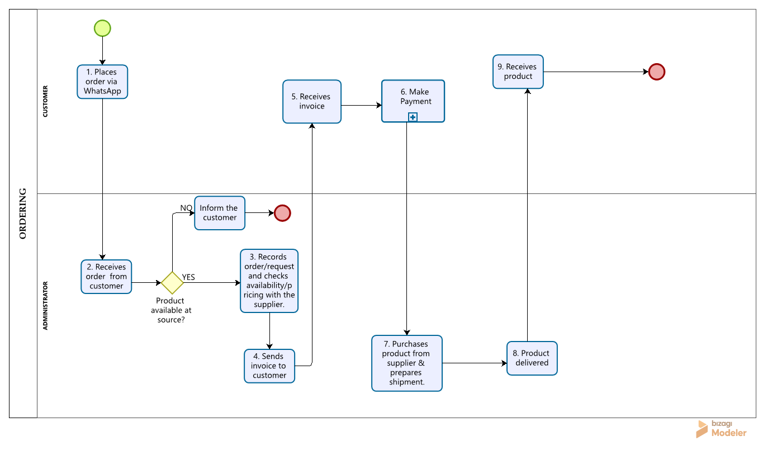
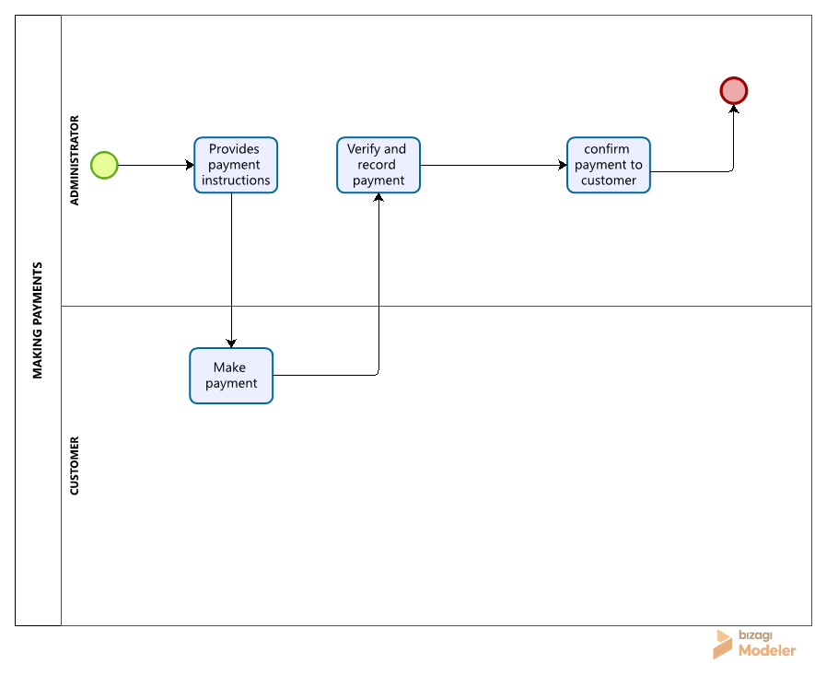
NARRATIVE
1) Customer communicates their product request to the client via WhatsApp. | 4) Client checks for availability of product requested at source.  - If available, proceeds to prepare pricing.  - If not available, client informs customer via WhatsApp that the product cannot be obtained and the process ends. | 7) Client verifies payment, purchases product from China supplier and prepares shipment.
2) Client receives the customer’s request and records details manually on paper. | 5) The customer receives the invoice containing total cost and payment instructions. | 8) Client ships and delivers product to the customer.
3) Client contacts external suppliers in China to check product availability and pricing. | 6) The customer makes the required payment through bank/Mobile money and sends proof of payment via WhatsApp. | 9) Customer receives product, completing the ordering process.

BUSINESS PROSPECTS (TO BE)
This is about the way business way will be carried out by the client after the system is introduced.
It involves the following classes:
- Customer
- Store keeper
- System manager
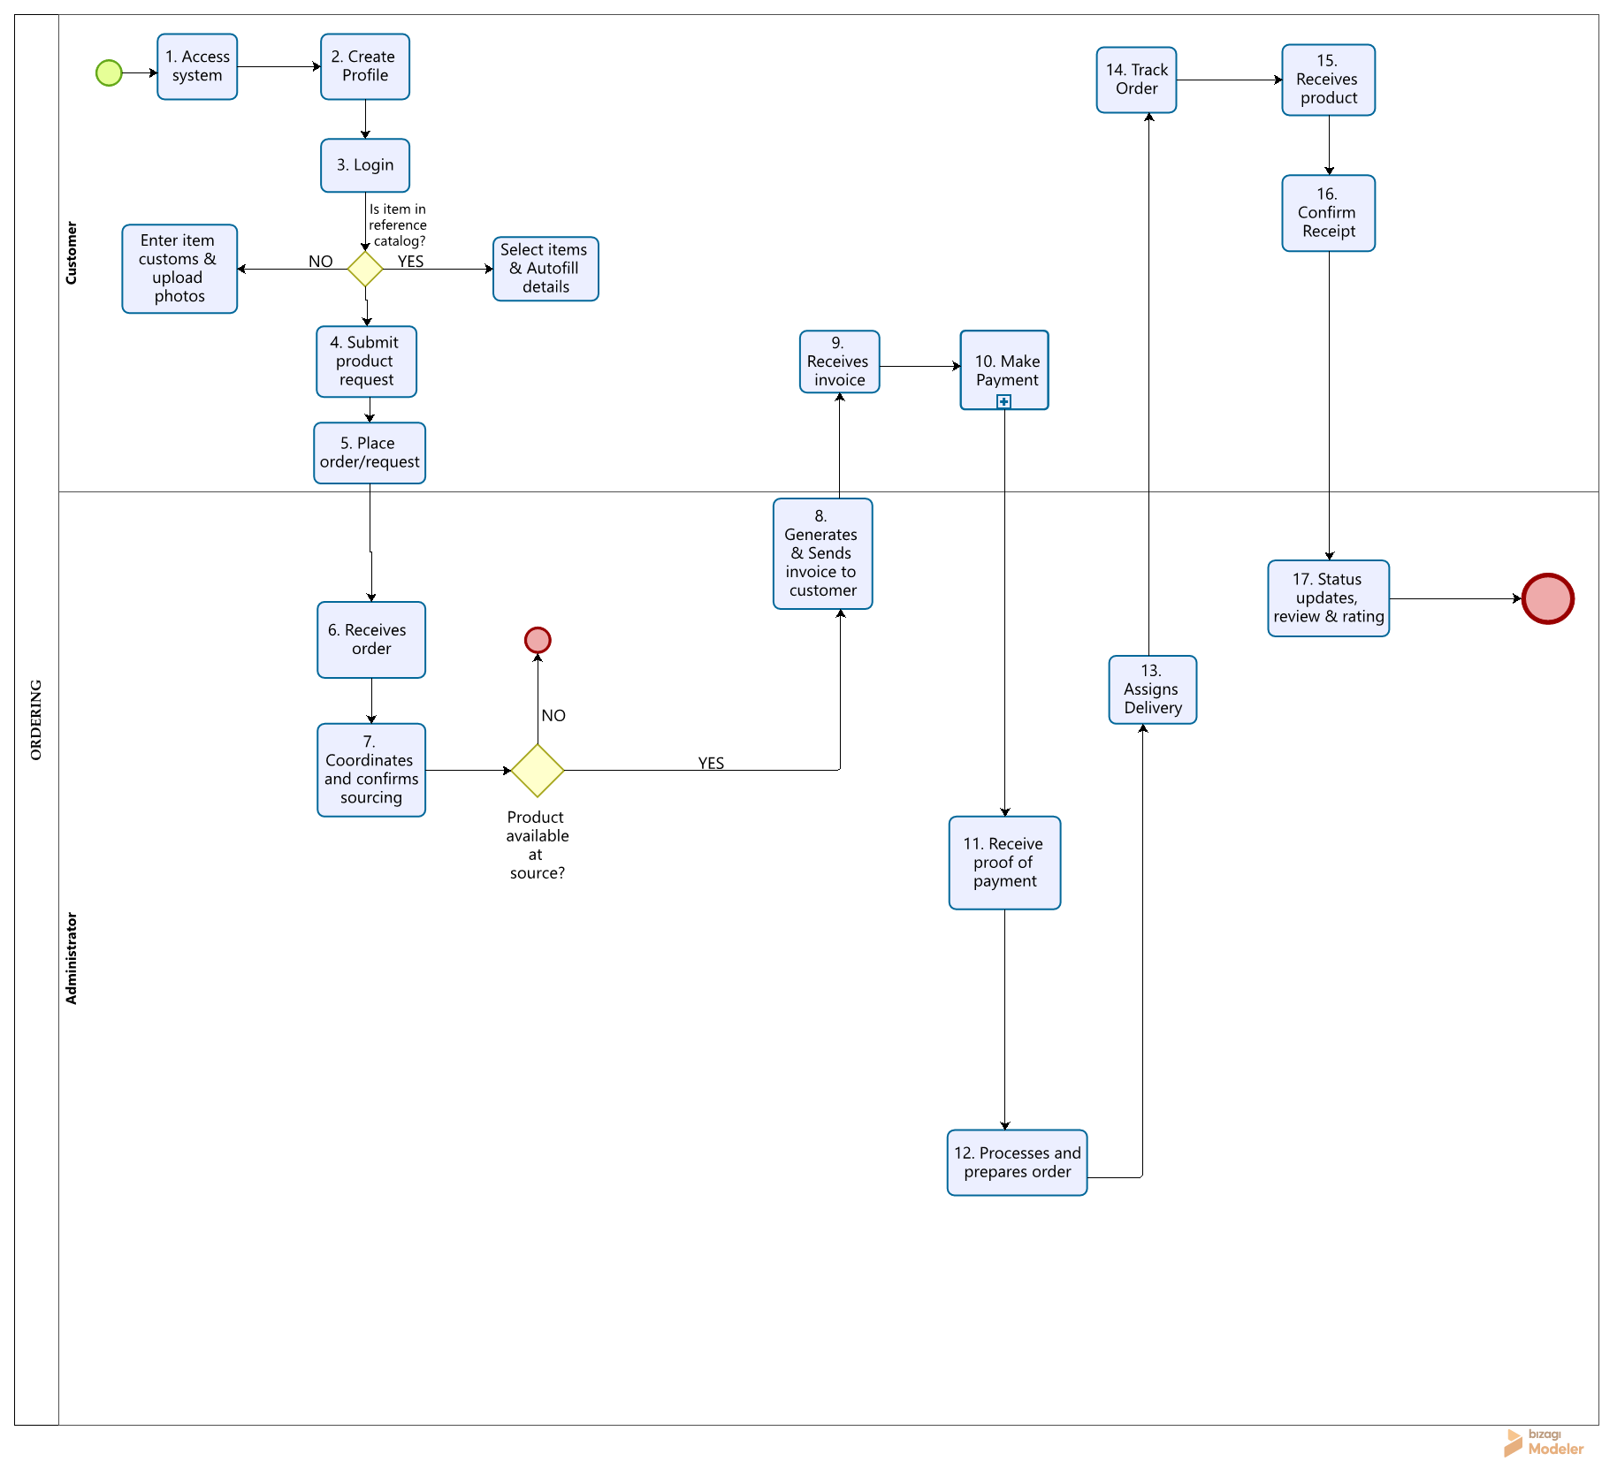
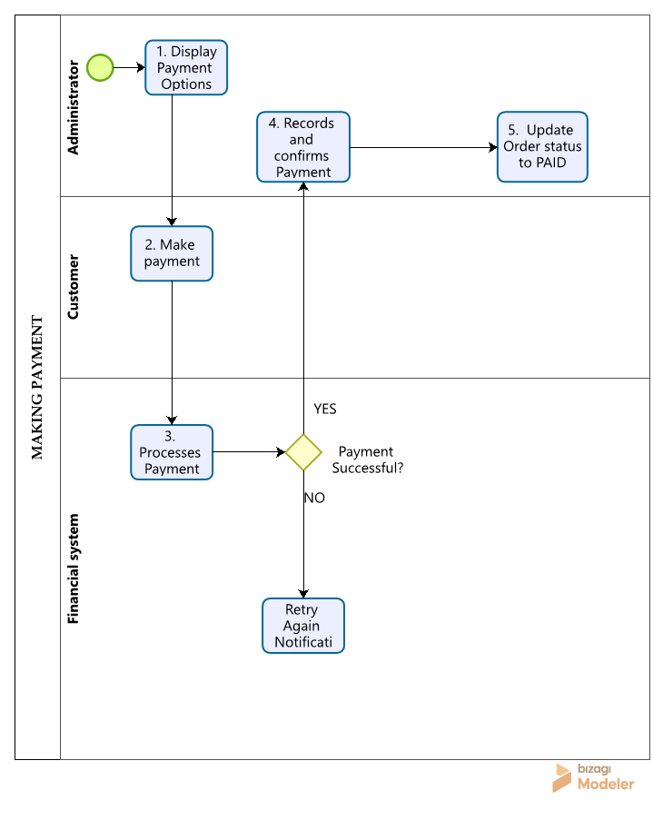
NARRATIVE
1) The customer accesses AgizaSafe web application landing view. | 4) The customer reference catalog item  (Selects item; system pre-populates basic details) or custom request (fills custom specification form). Also uploads reference photos/documents for custom request. | 7) The Administrator contacts China/external suppliers to verify availability, unit price and shipping duty/costs. | 9) Customer receives invoice alert and reviews cost breakdown. | 12) The administrator purchases product from the supplier and packs item. | 15) The customer receives physical shipment from courier.
2) The customer creates profile so their information can be stored and linked to future orders. | 5) The customer submits product request. System generates tracking ID e.g. #AG001 sets status to “ORDER PLACED”. | The administrator asks if product is available. If NO, Administrator sets status to “UNABLE TO SOURCE”, enters reason, system notifies customer and process ends. If YES, Administrator updates status to “SOURCING CONFIRMED” with locked unit price and costs. | 10) Customer selects payment option, completes payment, and uploads proof of payment. | 13) The administrator assigns packaged item to designated courier or shipping provider. | 16) The customer interactively confirms receipt of package within AgizaSafe system.
3) The customer logs into their registered account via email/phone and password to access the system. | 6) Administrator receives dashboard alert for new request. (#AG001) | 8) The administrator generates and sends itemized digital invoice (unit price, tax, shipping and total) to customer dashboard. | 11) Administrator reviews and verifies uploaded proof of payment by flagging order as PAID. | 14) The customer tracks real-time order status on horizontal visual tracker (Placed Sourced Purchased Arrived) | 17) System automatically updates status to “COMPLETED”, closes transaction, and prompts customer for 5-star rating and review.

FUNCTIONAL REQUIREMENTS
Ref no_ | Requirement | Role
FR-01 | The application should allow users to launch and access AgizaSafe application landing view. | Customer
FR-02 | The application should allow users to register by providing first, middle & last name, phone number (with country code picker), Email(optional), Business sector, Name & Address. | Customer/Administrator
FR-03 | Require login via email/phone number and password.  - Enforce Two-Factor Authentication (OTP verification) and password Recovery. | System
FR-04 | The application should enable logged-in customers to search and filter previously handled reference product information by product name, category or brand. | Customer
FR-05 | The application should allow the administrator to record, update and manage the sourcing/availability status (“Pending”, “Sourcing”, “Confirmed”. Or “Unable to source”) of a requested product after confirmation from the relevant product source. | Administrator
FR-06 | The application should provide interactive form capturing Product name, category, brand, Quantity, size, color, specifications/description, reference image/attachment representing customer product requirements, for customer to fill. | System
FR-07 | The application should automatically assign a unique tracking ID (e.g. #AG001) upon submission and push order details to administrator dashboard. | System
FR-08 | The application should automatically generate digital invoice detailing item breakdown, unit price, quantity, currency, taxes/duties, estimated shipping fee and total cost for sending it to customer. | System
FR-09 | The application should support customer payment submission across multiple currencies and provide proof of payment upload feature. | Customer
FR-10 | The application should allow Administrator to review, verify proof of payment and flag order as PAID | Administrator
FR-11 | The application should Trigger real-time dashboard notifications to Administrator immediately after order placement and payment verification. | Administrator
FR-12 | The application should display full order overview merging customer profile details with product parameters (size, color, brand, quantity) during order review, customer search and processing. | Administrator
FR-13 | The application should allow Administrator to update fulfillment stage to PREPARING/PURCHASED during physical pick and pack. | Administrator
FR-14 | The application should provide interface for Administrator to assign packaged orders to designated couriers or shipping options. | System/Administrator
FR-15 | The system should visually track and update progress through states:  Placed Confirmed Sourced Purchased Shipped Arrived Delivered COMPLETED | Customer/Administrator
FR-16 | The application should allow sending automated notifications to customers upon key status updates (e.g. “Your order #AG001 has been confirmed”) | Administrator/System
FR-17 | The application should allow customer to interactively confirm receipt upon physical arrival. | Customer
FR-18 | The application should automatically update master state to COMPLETED upon customer receipt confirmation and close transaction. | System
FR-19 | The application should provide Historical data table (Order ID, Customer, Product, Date, Quantity, Status) with multi-field search (Customer ID, Product ID, Date) | System
FR-20 | The application must allow logged-in users to manually terminate session from top navigation on all screens, clearing auth tokens and returning to Login screen | Customer/Administrator
FR-21 | The application shall display sourcing status of requested product or order, such as “Pending”, “Sourcing Confirmed”, or “Unable to Source”, and shall provide appropriate notifications/alerts to the customer. | System
FR-22 | Selecting an item from the available product information shall pre-populate relevant product details such as Product Name and Category into the order request form. Where a reference price is available, it may also be displayed subject to confirmation during the sourcing process. | System
FR-23 | The application must dynamically calculate and display Estimated Tax/Duty, Shipping Fee, and Grand Total, in real-time as item quantities or pricing parameters are adjusted on the order form when placing order. | System
FR-24 | The application must allow upload references photos (PNG, JPG, PDF up to 5MB) for custom item requests and payment receipts, rendering client-side thumbnail previews before form submission. | System
FR-25 | The application must render a horizontal step-by step visual tracker highlighting the active lifecycle stage (Placed, confirmed, sourced, shipped, delivered) with timestamps on the customer tracking view. | System
FR-26 | System must support data-range filtering, status filtering (Pending, Paid, Shipped, Completed) and CSV/PDF export capabilities on the Order History table. | System
FR-27 | The application must provide an interactive 5-star rating and comment submission form upon order completion. Storing user feedback against the specific Order ID and Product ID during receipt confirmation by customer. | System
Fr-28 | The application must maintain a real-time notification drop-down feed (accessible via top-bar bell icon) displaying unread badges, timestamped alerts and direct click-through links to order tracking views. | System

NON-FUNCTIONAL REQUIREMENTS
Ref no_ | Requirement
NFR 01 | Security: Customer & order information must be protected
NFR 02 | Performance: pages & actions should respond quickly
NFR 03 | Usability: System should be simple and easy to use
NFR 04 | Reliability: System should operate consistently without frequent failures.
NFR 05 | Availability: User should be able to access system when required.
NFR 06 | Data integrity: Customer, product and order records must remain accurate and consistent.
NFR 07 | Scalability: System should support increasing numbers of customers and orders.
NFR 08 | Maintainability: System should be easy to update, fix and maintain.
NFR 09 | Accessibility: System interface should be usable on common desktop and mobile screen sizes.
NFR 10 | Privacy: Customer information should be accessible to authorized users.

HARDWARE REQUIREMENTS
Hardware | Minimum Requirement | Use in the system
Administrator computer | Dual-core processor, 4 GB RAM, 128 GB storage | Used by the administrator to access the system, manage customers, record products, receive and process orders, search records, and update order status.
Customer device | Smartphone/computer with at least 2 GB RAM | Used by customers to create accounts, log in, enter product requirements, place orders, view orders, and track order status.
Server | Quad-core processor, 8 GB RAM, 256 GB SSD | Hosts AgizaSafe application and database, processes requests from users and stores customer, product and order information.
Network/Internet | Stable Internet connection | Enables communication between customer devices, administrator computers and the AgizaSafe server, allowing users to access an update the system.
Backup storage | External/cloud storage | Used to create backups of important customer, product and order data and restore information in case of data loss or system failure.

ASSUMPTIONS & CONSTRAINTS
ASSUMPTIONS
• Customers have access to an Internet-enabled device.
• Customers provide accurate information when placing orders.
• The administrator regularly updates order statuses.
• The business has reliable Internet connectivity.
• The administrator has access to the system.
• Product and customer information will be entered accurately.
CONSTRAINTS
• Internet availability.
• Cost of hosting and infrastructure.
• Availability of accurate customer information.
• Limited technical skills among some users.
• Dependence on external communication or payment services when these are introduced

ACCEPTANCE CRITERIA
The system shall be considered functionally acceptable if can complete these core activities successfully:
- A customer can:
  - Create an account
  - Log in
  - Submit order
  - Submit request for product that is not already listed in the available product information
  - View updated status
  - Track order
  - Receive appropriate order notifications
- Administrator can:
  - Receive and Review a customer product request and update its sourcing/availability status.
  - Update the order status
  - Search customer and order records
- Previous orders can be retrieved
- Unauthorized users cannot access restricted administrative functions

DATA DICTIONARY (Phase 1)

User
ColumnName | DataType | Size | IsNull | IsUnique | IsPrimaryKey | IsForeignKey | ForeignKeyReference | IsAutoIncrement | Description
Id | NUMERIC | 11 | NO | YES | YES | NO | - | YES | Uniquely identifies each system user. It is used as the main reference for identifying who created or updated records. Without it, records could not be reliably linked to a specific user.
PhoneNumber | TEXT | 20 | NO | YES | NO | NO | - | No | Store the user’s phone number for identification and communication. It is unique so that one phone number cannot be associated with multiple user accounts. Without it, phone-based identification and communication would be difficult.
Email | TEXT | 100 | YES | YES | NO | NO | - | NO | Stores user’s email address for communication and where applicable, account access. It is unique to prevent multiple accounts from using the same email.
PasswordHash | TEXT | 255 | NO | NO | NO | NO | - | NO | Stores securely hashed version of the user’s password rather the actual password. Without it, the system would not have a secure way to authenticate users.
CreatedAt | DATETIME | - | NO | NO | NO | NO | - | NO | Records when the user account was created. This provides an audit trail and helps determine the age of an account.
UpdatedAt | DATETIME | - | YES | NO | NO | NO | - | NO | Records the most recent date and time the user’s information was changed. Without it, would be difficult to determine when the account information was last modified.
CreatedBy | NUMERIC | 11 | NO | NO | NO | YES | User.Id | NO | Identifies the user who created the record. It provides accountability for record creation.
UpdatedBy | NUMERIC | 11 | YES | NO | NO | YES | User.Id | NO | Identifies the user who last modified the record. It provides accountability for changes made to user information.

Customer
ColumnName | DataType | Size | IsNull | IsUnique | IsPrimaryKey | IsForeignKey | ForeignKeyReference | IsAutoIncrement | Description
Id | NUMERIC | 11 | NO | YES | YES | NO | - | YES | Uniquely identifies each customer. It is used by orders and other customer-related records to identify the customer placing an order.
FirstName | TEXT | 50 | NO | NO | NO | NO | - | NO | Stores the customer’s first name. It is needed to identify the customer address them correctly.
MiddleName | TEXT | 50 | YES | NO | NO | NO | - | NO | Stores the customer’s middle name where applicable. It is optional because not every customer has one.
LastName | TEXT | 50 | NO | NO | NO | NO | - | NO | Stores the customer’s surname or family name. It helps identify the customer and distinguish them from other customers.
BusinessSector | TEXT | 100 | YES | NO | NO | NO | - | NO | Stores the business sector in which the customer operates, where applicable. It provides additional information about the customer’s business needs.
BusinessName | TEXT | 150 | YES | NO | NO | NO | - | NO | Stores the customer’s business name when the customer is ordering for a business. It allows orders and customer records to be associated with the relevant business.
BusinessAddress | TEXT | 255 | YES | NO | NO | NO | - | NO | Stores the customer’s business or delivery-related address information. It supports identifying where the customer’s business is located or where relevant business information should be associated.
CreatedAt | DATETIME | - | NO | NO | NO | NO | - | NO | Records when the customer record was created.
UpdatedAt | DATETIME | - | YES | NO | NO | NO | - | NO | Records when the customer’s information was last updated.
CreatedBy | NUMERIC | 11 | NO | NO | NO | YES | User.Id | NO | Identifies the user who created the customer record.
UpdatedBy | NUMERIC | 11 | YES | NO | NO | YES | User.Id | NO | Identifies the user who last updated the customer record.

TblListSource
ColumnName | DataType | Size | IsNull | IsUnique | IsPrimaryKey | IsForeignKey | ForeignKeyReference | IsAutoIncrement | ExampleValue | Description
Id | NUMERIC | 11 | NO | YES | YES | NO | - | YES | 1 | Uniquely identifies each list-source record in the database.
Code | TEXT | 100 | NO | YES | NO | NO | - | NO | ORDER_STATUSES.CREATED | Stores a unique system code used to identify a specific list value.
Text | TEXT | 100 | NO | NO | NO | NO | - | NO | Created | Stores the human-readable value displayed to users.
Description | TEXT | 255 | YES | NO | NO | NO | - | NO | Order has been created. | Explains the meaning and purpose of the list value.
ListName | TEXT | 100 | NO | NO | NO | NO | - | NO | OrderStatuses | Identifies the group to which the list value belongs, such as OrderStatuses or ProductCategories.
IsActive | BOOLEAN | 1 | NO | NO | NO | NO | - | NO | True | Indicates whether the list value is currently available for use.
CreatedAt | DATETIME | - | NO | NO | NO | NO | - | NO | 2026-09-07 10:00:00 | Records when the list-source record was created.
UpdatedAt | DATETIME | - | YES | NO | NO | NO | - | NO | 2026-09-07 10:30:00 | Records when the list-source record was last modified.
CreatedBy | NUMERIC | 11 | NO | NO | NO | YES | User.Id | NO | 1 | Identifies the user who created the record for audit-trail purposes.
UpdatedBy | NUMERIC | 11 | YES | NO | NO | YES | User.Id | NO | 1 | Identifies user who last modified the record for audit-trail purposes.

Currency
ColumnName | DataType | Size | IsNull | IsUnique | IsPrimaryKey | IsForeignKey | ForeignKeyReference | IsAutoIncrement | Description
Id | NUMERIC | 11 | NO | YES | YES | NO | - | YES | Uniquely identifies a currency in the system. Other tables use this ID when referring to a currency.
Code | TEXT | 3 | NO | YES | NO | NO | - | NO | Stores the standard three-letter currency code, such as TZS, USD, or a CNY. It provides a consistent way of identifying currencies.
Name | TEXT | 50 | NO | YES | NO | NO | - | NO | Stores full name of the currency such as Tanzanian Shilling, US Dollar or Chinese Yuan.
Symbol | TEXT | 10 | YES | NO | NO | NO | - | NO | Stores the commonly used symbol of the currency, such as TSh or $. It is used when displaying monetary values to users.

Product
ColumnName | DataType | Size | IsNull | IsUnique | IsPrimaryKey | IsForeignKey | ForeignKeyReference | IsAutoIncrement | Description
Id | NUMERIC | 11 | NO | YES | YES | NO | - | YES | Uniquely identified each product in the system. Orders use this ID to identify which product was requested.
CategoryId | NUMERIC | 11 | NO | NO | NO | YES | TblListSource.Id | NO | Identifies the category assigned to the product by referencing a Lookup record whose Type is CATEGORY. Using a reference prevents category names from being repeatedly stored as text.
Name | TEXT | 150 | NO | NO | NO | NO | - | NO | Stores product name used to identify and display the product to customers.
UnitPrice | DECIMAL | 12,2 | NO | NO | NO | NO | - | NO | Stores price of one unit of the product. It is needed to calculate order costs and show the customer the product price.
CurrencyId | NUMERIC | 11 | NO | NO | NO | YES | Currency.Id | NO | Identifies the currency in which the product price is expressed. Without it, numerical price is expressed. Without it, the numerical price could be misunderstood because currency would be unknown.
Description | TEXT | - | YES | NO | NO | NO | - | NO | Provides additional information about the product such as its features, specifications, or other details useful to the customer.
CreatedAt | DATETIME | - | NO | NO | NO | NO | - | NO | Records when the product record was created.
CreatedBy | NUMERIC | 11 | NO | NO | NO | YES | User.Id | NO | Identifies the user who created the product record.
UpdatedAt | DATETIME | - | YES | NO | NO | NO | - | NO | Records when the product information was last modified.
UpdatedBy | NUMERIC | 11 | YES | NO | NO | YES | User.Id | NO | Identifies the user who last modified the product record.

Order
ColumnName | DataType | Size | IsNull | IsUnique | IsPrimaryKey | IsForeignKey | ForeignKeyReference | IsAutoIncrement | Description
Id | NUMERIC | 11 | NO | YES | YES | NO | - | YES | Uniquely identifies each order internally in the database. It is used to connect the order with its order details and customer.
OrderNumber | NUMERIC | 20 | NO | YES | NO | NO | - | NO | Stores the unique number used to identify an order to users and for order tracking. Without it, it would be harder to refer to a specific order externally.
CustomerId | NUMERIC | 11 | NO | NO | NO | YES | Customer.Id | NO | Identifies the customer who placed the order. Without it, the system could not determine who the order belongs to.
OrderDate | DATETIME | - | NO | NO | NO | NO | - | NO | Records the date and time when the order was placed.
StatusId | NUMERIC | 11 | NO | NO | NO | YES | TblListSource.Id | NO | Identifies the current status of the order by referencing a Lookup record whose Type is OrderStatus. This allows statuses such as Created, Cancelled, Processed, On Transit, Delivered to be centrally managed.
ExchangeRate | DECIMAL | 12,6 | YES | NO | NO | NO | - | NO | Stores exchange rate applicable to the order when currency conversion is required. Keeping the rate with the order preserves the rate used for that transaction .
Total | DECIMAL | 12,2 | NO | NO | NO | NO | - | NO | Stores total monetary value of the order. It allows the system to display and work with the overall order amount without recalculating it every time.
CurrencyId | NUMERIC | 11 | NO | NO | NO | YES | Currency.Id | NO | Identifies the currency in which the order total is expressed.
CreatedAt | DATETIME | - | YES | NO | NO | NO | - | NO | Records when order was created.
CreatedBy | NUMERIC | 11 | YES | NO | NO | YES | User.Id | NO | Identifies the user who created the order record.

OrderDetails
ColumnName | DataType | Size | IsNull | IsUnique | IsPrimaryKey | IsForeignKey | ForeignKeyReference | IsAutoIncrement | Description
Id | NUMERIC | 11 | NO | YES | YES | NO | - | YES | Uniquely identifies each individual item/line within an order. One order can therefore contain multiple order-detail records.
ProductId | NUMERIC | 11 | NO | NO | NO | YES | Product.Id | NO | Identifies the product being requested in this order detail. Without it, the system could not determine which product the customer ordered.
OrderId | NUMERIC | 11 | YES | NO | NO | YES | Order.Id | NO | Identifies the order to which the detail belongs to. This connects individual products to their overall customer order.
Quantity | NUMERIC | 11 | NO | NO | NO | NO | - | NO | Stores the number of units of the product requested by the customer. It is required to calculate total cost for the line.
UnitPrice | DECIMAL | 12,2 | NO | NO | NO | NO | - | NO | Stores the price of the one unit at the time the order detail was created. Keeping it here preserves the price used for the particular order even if the product’s current price changes later.
CurrencyId | NUMERIC | 11 | NO | NO | NO | YES | Currency.Id | NO | Identifies currency associated with the unit price and total amount for this order-detail.
Total | DECIMAL | 12,2 | NO | NO | NO | NO | - | NO | Stores Total amount for the order-detail line, normally calculated from Quantity x UnitPrice.
ExchangeRate | DECIMAL | 12,6 | YES | NO | NO | NO | - | NO | Stores exchange rate applicable to this particular order detail when currency conversion is needed.
CreatedAt | DATETIME | - | NO | NO | NO | NO | - | NO | Records when order-detail record was created.
CreatedBy | NUMERIC | 11 | NO | NO | NO | YES | User.Id | NO | Identifies the user who created order-detail record.

CONCLUSION
AgizaSafe is intended to solve the difficulties created by managing an increasing number of customer requests and orders through handwritten records and WhatsApp conversations.
The proposed system will provide a centralized digital environment for managing customer information, product/item requests, order placement, product sourcing coordination, invoicing, payment records, order processing, status updates, order tracking, order history and customer notifications.
The system recognizes that Lisa acts as a link between customers and relevant product sources rather than being main source or owner of the products requested by customers. Therefore, product information within the system serves mainly as a reference, while actual product availability and sourcing are confirmed during the order-processing process.
The system will initially focus on the core order-management and product-sourcing coordination requirements and can subsequently be expanded with additional functionality as the business grows.

